A picture containing clipart

Description generated with very high confidence

Hands-on

Creating a Global Accelerator

AWS Solutions Architect

[**support@intellipaat.com**](mailto:support@intellipaat.com)

**+91-7022374614**

**US: 1-800-216-8930(Toll Free)**

**Creating a Global Accelerator**

**Step 1:** Open the Global Accelerator console and click on Create Accelerator

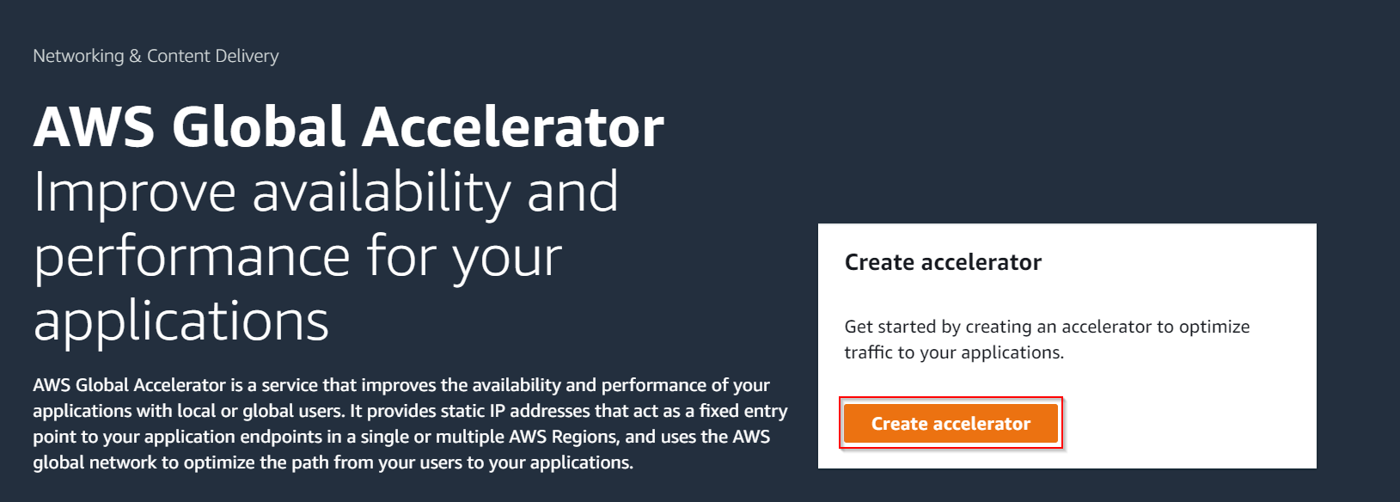

**Step 2:** Give a name for the Accelerator and click next

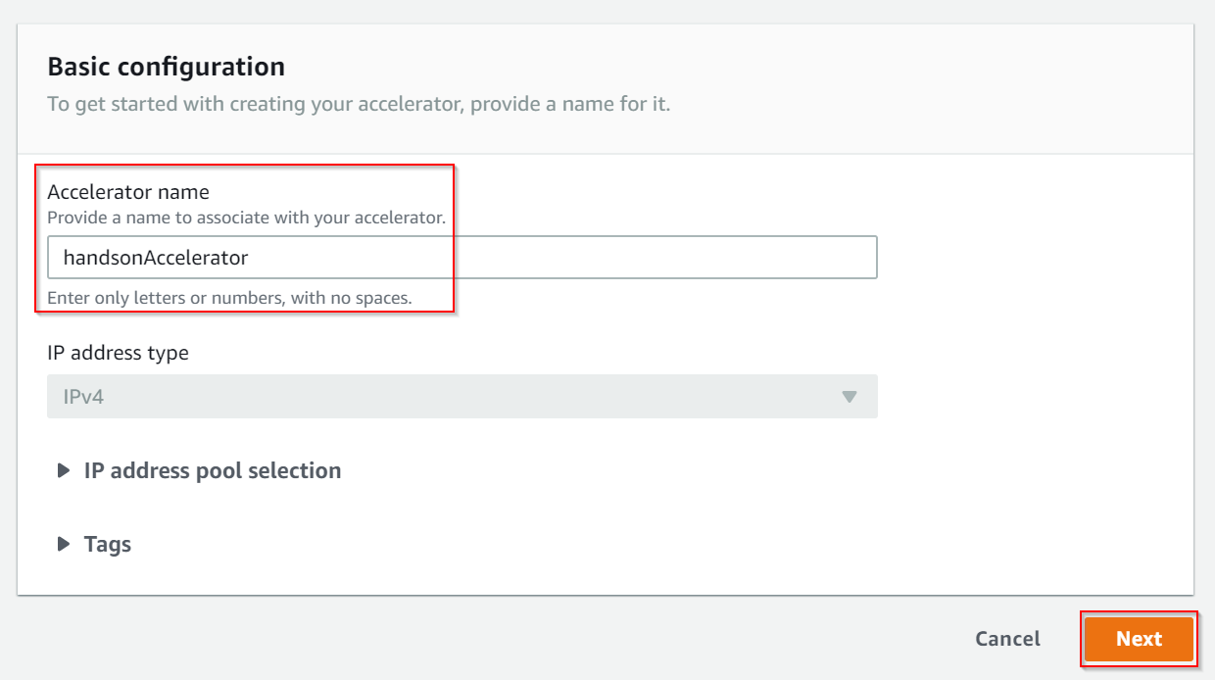

**Step 3:** Add a listener for the port number of your webserver

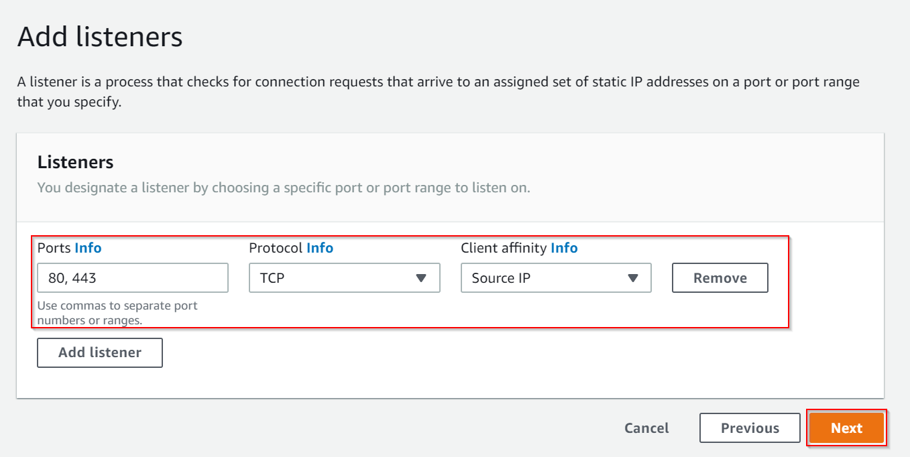

**Step 4:** Choose the region which has your instances or your load balancers

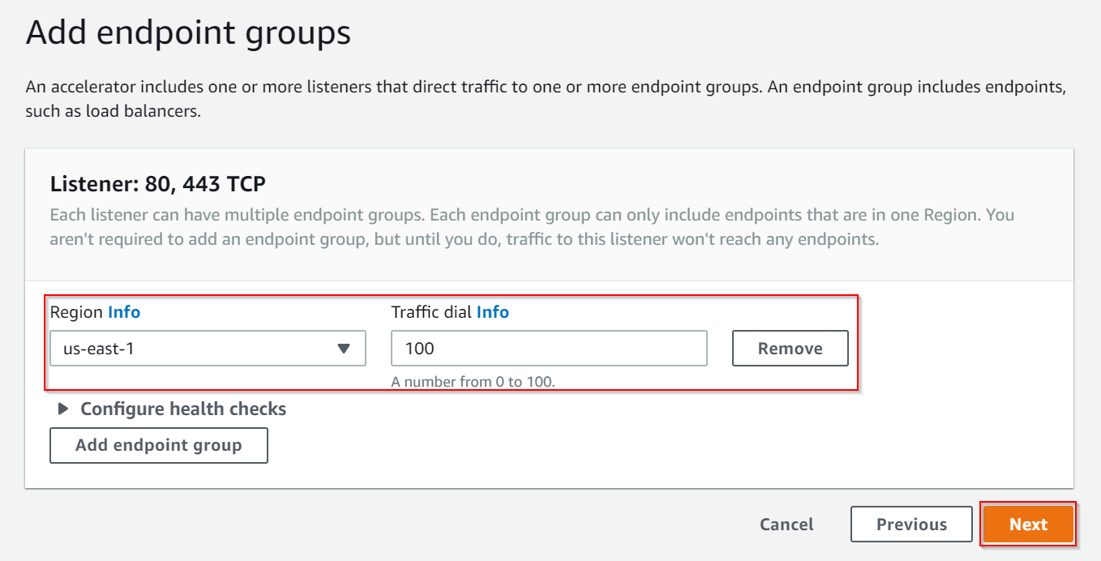

**Step 5:** Choose all your endpoints. Here two EC2 instances are added as the endpoint. Once you have added the Endpoints, click on Create accelerator.

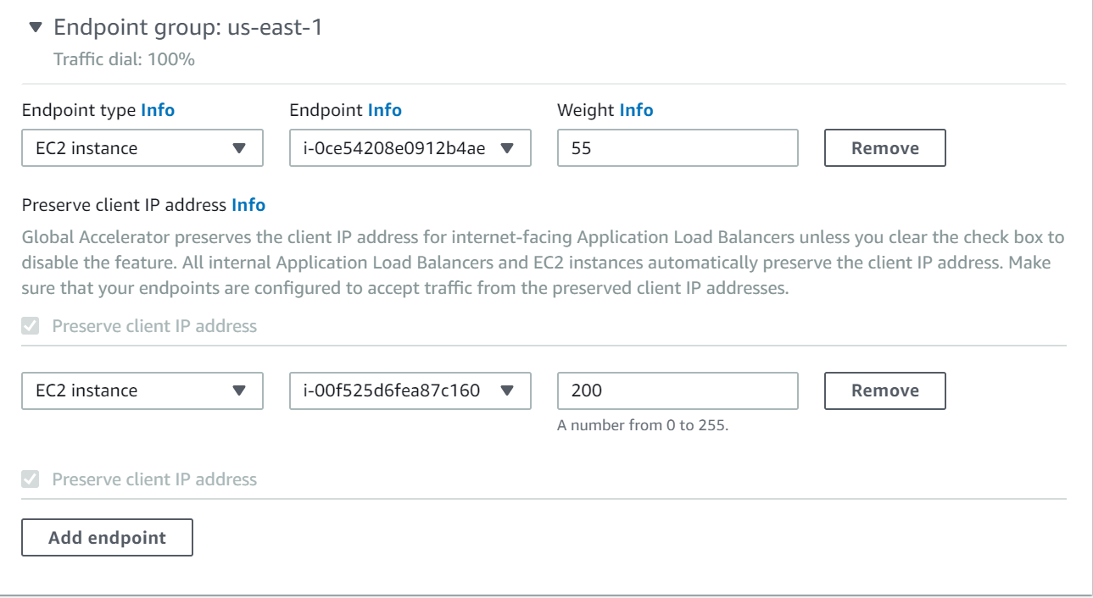

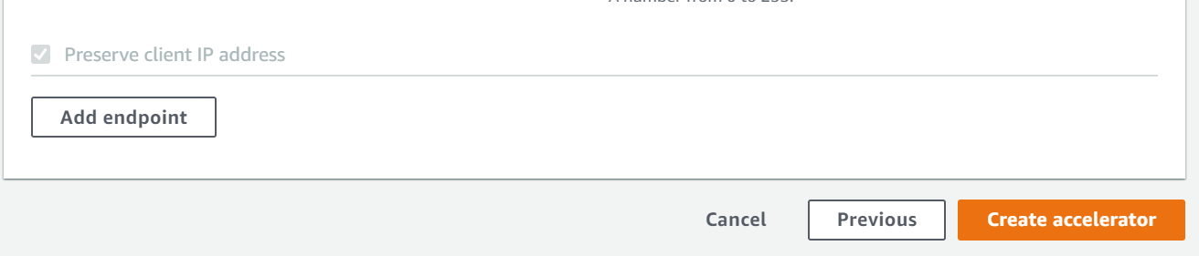

**Step 6:** Here you have received 2 static IP address and a DNS name which you can use to access all the endpoints.

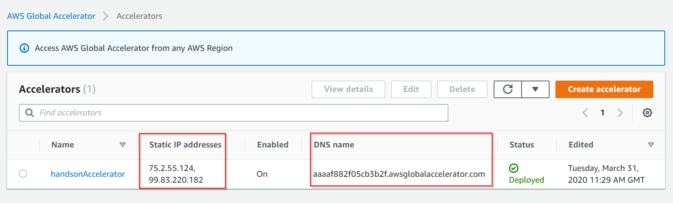

**Step 7:** For example, here I have used the static IP address to access one website from a server.

